# NFC-X Product Manual

1.DOWNLOAD

<https://www.camelote.cn/nfctools/>

Visit this URL to download. When the device is plugged into the computer, the pop-up USB drive also contains a web link. 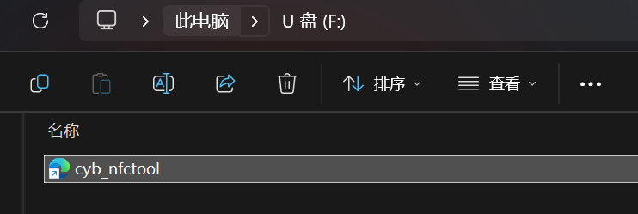

2. Introduction to Software Interface Functions

After opening the software, the left side allows switching between: Language, High-frequency Card, Low-frequency Card, Version Control (Device Upgrade), Call Device (Find Device)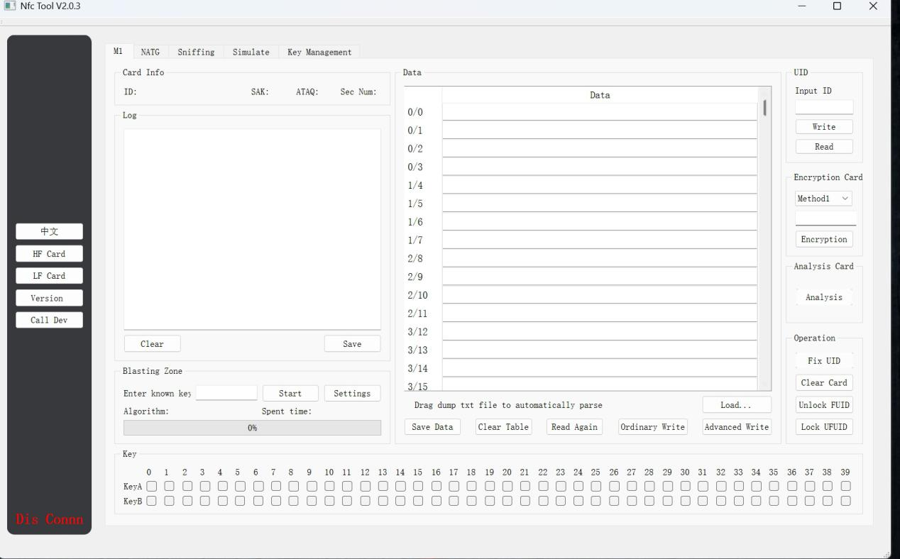

When the software is opened, it will automatically connect to the device; there is no need to select a port or driver. Please connect the device using a data cable, not a charging cable that does not support data transmission. The device supports reading and writing of high-frequency IC cards such as 1K, 2K, 4K, QL88, 1-3 generation non-vulnerable cards, hard cards, UID, CUID, UFUID, FUID, GDM, NTAG213, NTAG215, NTAG216, etc. For low-frequency cards, it supports reading and writing of cards such as 4100, 4305, 5577, 5200, 8265, 8210, 8268, 8310, HID operating within the 125KHZ-500KHZ range.

3.Reading and Writing of High-Frequency Cards (Classic Series)

Place the card on the induction area of the device. The device's buzzer will emit two consecutive beeps to remind the user that the device has recognized a high-frequency card using the 1443A protocol. If the buzzer beeps only once, it indicates that the placed card is a low-frequency card. If the device does not emit any beeps, it means the placed card cannot be recognized (please move it to another position) or the placed card is not of a type supported by the device. 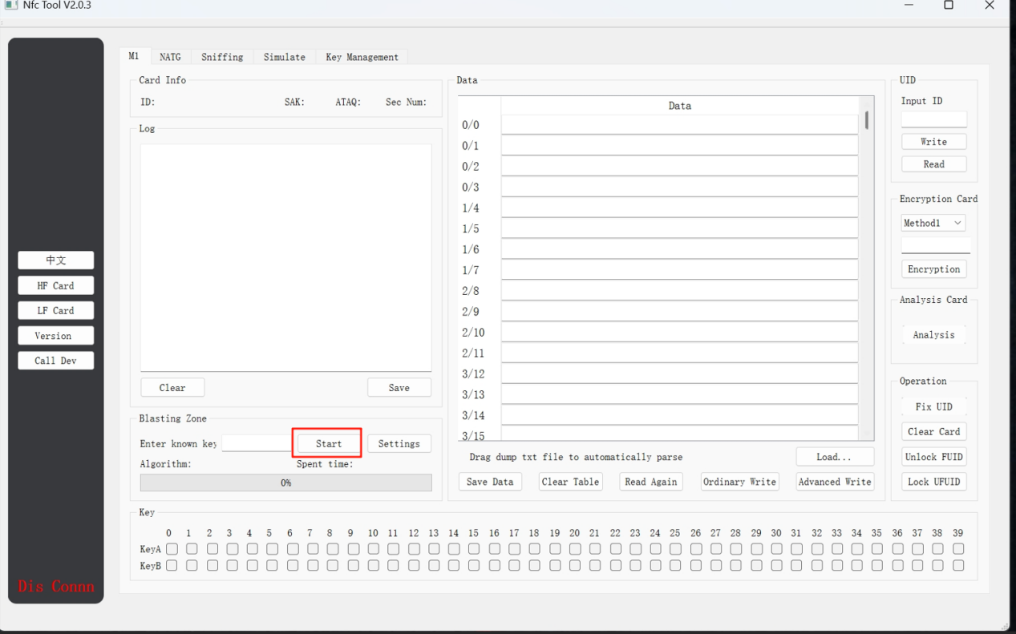

After placing the card properly, click "Start". The device will begin reading card data, and a checkmark (√) below indicates that the password for that sector has been obtained. During decryption, the device will display the progress and elapsed time. Depending on the card type, the reading time may range from a few seconds to several tens of minutes. The decryption speed of some cards is related to the CPU performance of the computer, so please wait patiently during the decryption process. Do not move the card while decryption is in progress.

For card duplication, "Advanced Write" must be used. "Advanced Write" uses backdoor commands for writing, and generally does not require key verification. Of course, for cards without backdoor commands, it will automatically execute "Ordinary Write". "Ordinary Write" is a standard writing mode that requires key verification.

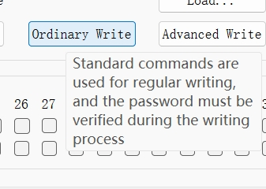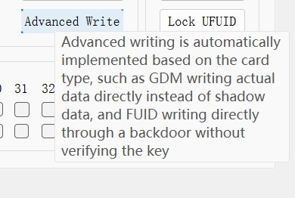

When the card writing is completed, the software will prompt the number of blocks that have been successfully written. If there are failed blocks, the data area on the right will be marked in red. Users need to check the reasons for the failed writing before trying again. Common reasons for failed writing include: the card is a non-duplicable card with an unchangeable card number; the card is not a blank card and the key does not match that of the data area; the card sectors are locked; or the card signal is weak. 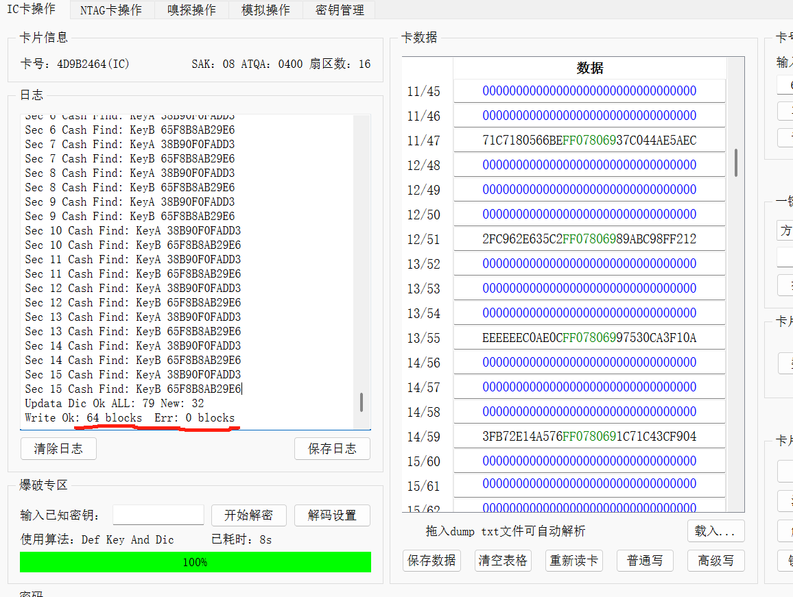

The special function buttons at the bottom right can be used to repair UID cards that have been compromised by firewalls, clear the card (format the card), unlock some FUID cards, and lock UFUID cards.

If you only need to copy the card number, you can enter or read the card number, then replace the card and click "Write Card Number". This operation supports UID, CUID, FUID, UFUID, 4K duplicable cards, 7-byte duplicable cards, etc. 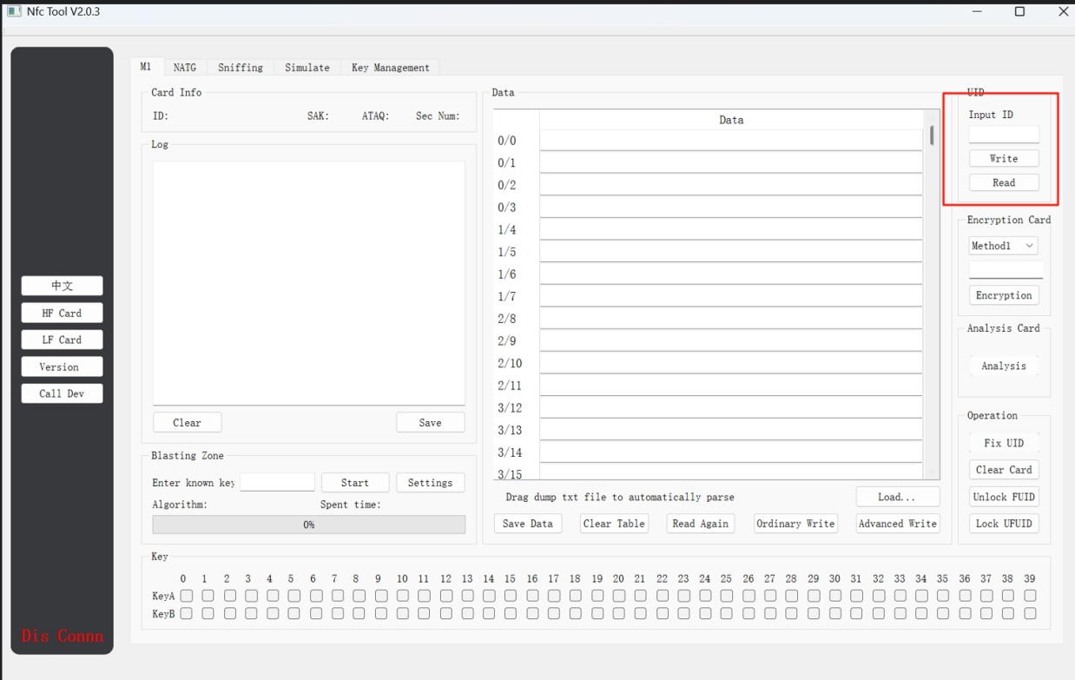

For cards that cannot be cracked, you can decrypt them by filling in the key after sniffing or using the cloud dictionary.

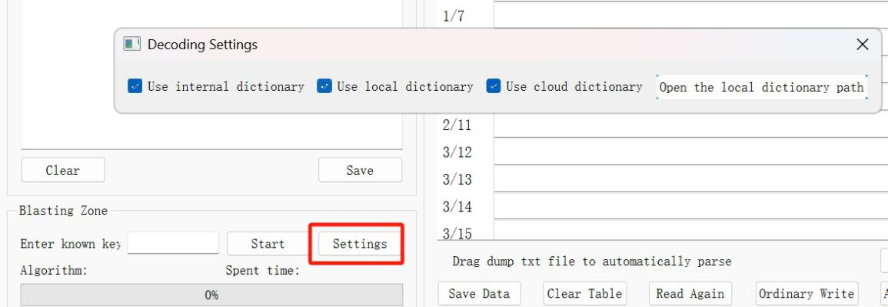

Fill in the known password, check "Use Cloud Dictionary", and then click "Start

4.HFcard write（NTAG）

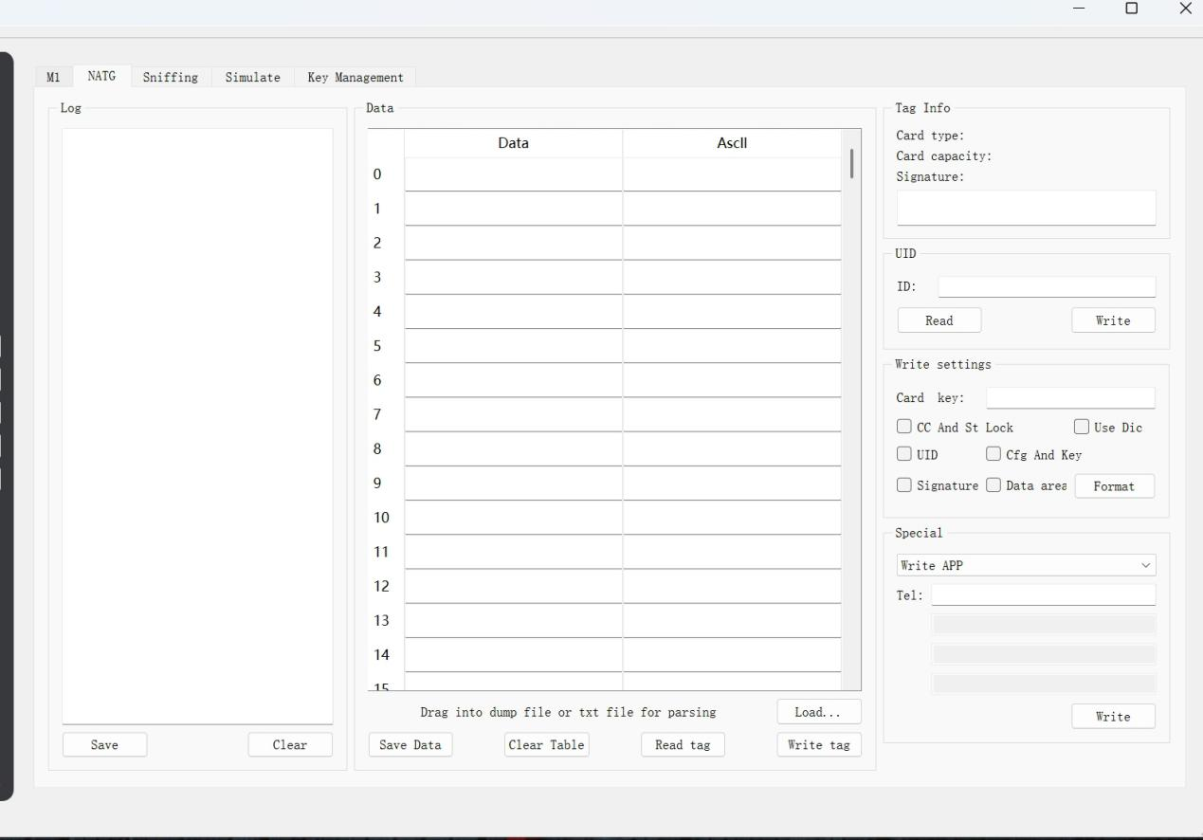

After placing the NTAG tag, you can read from and write to the tag. For encrypted cards, you can enter the password on the right side before reading. When writing to the card, if you have special requirements, you can select the areas to be written; if no areas are selected, only the data area will be written by default. The software supports writing the following information to NTAG cards: phone numbers, URLs, WiFi credentials, Bluetooth information, apps (requires entering the application package name), and business cards.

5.LF CARD WRITE（ID/HID...）

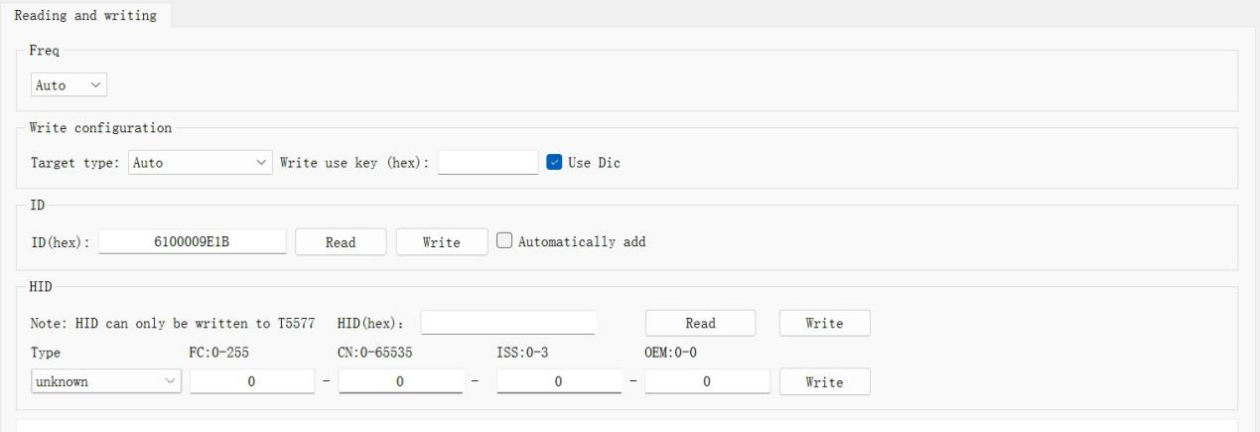 After placing the card properly, the device will emit a "beep" sound, indicating that the card has been recognized. However, if a brand-new card of type 5577 or 4305 is placed, the device will not emit a "beep". Click "Read Card", and the device will automatically scan frequencies from 125KHz to 500KHz. Once the reading is successful, the card information will be displayed. At this point, you can replace it with a new card and click the "Write ID" button to duplicate the card. If you have special needs, you can check the "Auto-increment Card Number by 1 When Writing" function; when checked, the card number will increase by 1 for each writing operation.

The device also supports other low-frequency cards such as HID, and the supported types can be viewed in the drop-down menu. Click the "Read" button on the left side of the HID section. Without specifying a card type, the device will automatically scan the card type and display data such as the card number after successful reading. After a successful reading, you can replace the card and click the "Write" button to duplicate the card. Alternatively, you can select a specified format type, enter information such as FN/CN, and then click "Write". The device will then write the information specified by the user.

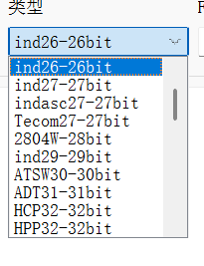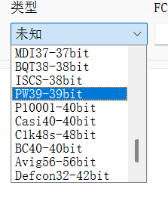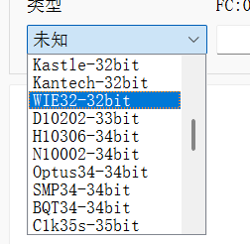

6.update

If there are device updates in the future, you can download the latest upgrade package from the software's official download website, drag it into the red-framed area, and wait for the device upgrade to complete. Please ensure a stable USB connection during the upgrade process. 